By: Patience T. Quiah

Ethical principles in nursing
Nursing Case Studies
table of content
Seven general ethical principles in nursing……………………………………………….page 2-3

Introduction……………………………………………………………………………….page 4

Body (research)……identifying these principles…………………………………...…….page 5

Conclusion…………………………………………………………………………………page 6

Work Cited…………………………………………………………………………………page 7

Seven general ethical principles in Nursing
- Non-Maleficence
  - ✓ Will no one be harmed by the proposed intervention?
  - ✓ Are especially children prevented from harm?
- Beneficence
  - ✓ Is the intervention of any good to every single person taking part in this intervention?
  - ✓ Overall, for both non-maleficence and beneficence, is it possible to assess whether more benefit than harm is produced by intervening (or not intervening) and, if so, on what side (benefit or harm) does the equation finally fall?
- Health Maximisation
  - ✓ Is the proposed intervention effective and evidence-based? Does it improve population health?
  - ✓ Does it have a sustainable, long-term effect on the public’s health?
  - ✓ Is there a community added value to the proposed intervention?
- Efficiency
  - ✓ Is the proposed intervention cost-effective?
  - ✓ Awareness of scarcity of public money; saved money can be used for other goods and services.
- Respect for Autonomy
  - ✓ Does the intervention refrain from employing coercion and manipulation? Does it foster free choice?
  - ✓ Is there really ‘informed consent’ to take part in the intervention?
  - ✓ Is self-responsibility not only demanded but also possible for every person?
  - ✓ Are privacy and personal data respected?
  - ✓ If the intervention is paternalistic, is this justifiable?
  - ✓ Does the intervention promote the exercise of autonomy?
- Justice
  - ✓ Is no one (including third parties) stigmatised, discriminated against or excluded as a consequence of the proposed intervention?
  - ✓ Is the institution proposing the intervention publicly justified and acting transparently?
  - ✓ Is the proposed intervention not putting sub-populations at risks of being excluded from social benefits and/or universal access to health care?
  - ✓ Does the intervention exacerbate social and health inequalities (inequities)? Does it fight inequalities (inequities)?
  - ✓ Does the intervention consider and support vulnerable sub-populations (e.g. migrants)?
  - ✓ Does the intervention promote rather than endanger fair (and real) equality of opportunity and participation in social action?
  - ✓ Does the intervention refrain from eroding a sense of social cohesion and solidarity?
- Proportionality
  - ✓ Is the intervention the least infringing of possible alternatives?
  - ✓ Are costs and utility proportional?

Introduction

Why case studies?
Case studies in this context are short narratives describing a real-world or at least realistic example of a professional ethical dilemma. Case studies have a central role in the process of teaching and learning that aims to build the capacity of moral awareness and discrimination. The use of case studies has been widespread and successful in various areas of medical ethical education generally and bioethics more particularly. They also have a history of success in public health, in particular public health ethical-scientific discourse. Case studies are not simply ‘administered’. Their form demands, and their function yields, dynamic group discussions in which the participants’ specific professional and personal experience can be brought to bear on the problem highlighted within the case concerned.

Research

Case study: Maria Morales
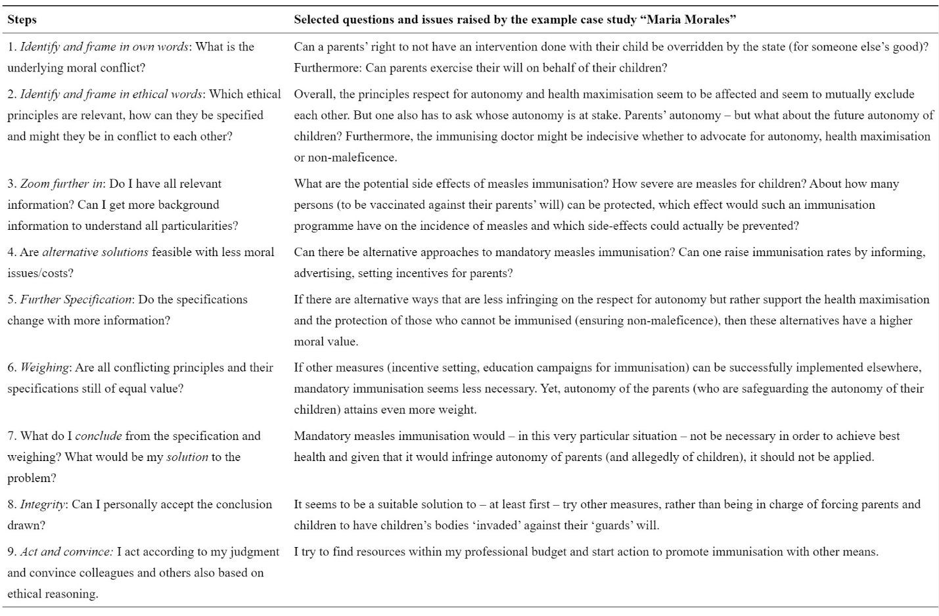
This case was about Maria Morales, head of the “Infectious Disease Control” unit of the Ministry of Health of the State X, is asked by her minister to make a suggestion if measles immunization should be made mandatory in their region as recently 2 children died after a measles outbreak. State X has an insufficient immunization rate (1st dose 70%, 2nd 55%). Maria finds out that obligatory measles immunization is effectively implemented in regions in Hungary and the Czech Republic. She knows her minister is taking her advice most seriously. What should she do?

Conclusion
An important benefit of a case study-type approach centrally embedded in public health ethics teaching and learning is that it allows access to an enormous range of sources and experience. There is perhaps a tendency to think of case studies as artefacts solely designed by those charged with the teaching and learning process. Of course, the development and use of case studies designed by those teaching short courses in ethics is important. But student-generated experience as material for case studies is equally, if not more, valuable because it is rooted in the professional lives of learners. Sources such as books (both fiction and non-fiction) and films are also rich veins that can be tapped in the search for source material for ethics-related case studies

Work Cited
https://www.ncbi.nlm.nih.gov/
https://bmcmedethics.biomedcentral.com/
Biomedical ethics scholarly review

